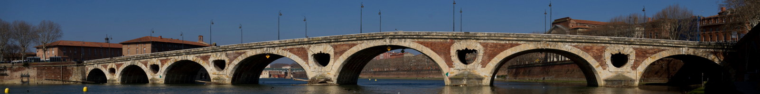

WoSAR: The 9th International Workshop on Software Aging and Rejuvenation

October 23-26, 2017, Toulouse, France, co-located with ISSRE 2017

https://wosar2017.wordpress.com

Software aging is a problem of progressive degradation of performance and dependability in computer programs, especially those executing for long period of time. This phenomenon has been extensively studied since more than 20 years, as it affects many systems, from embedded devices to server software to critical systems.

Software rejuvenation, i.e. restart of application (components/threads/task), VMs or machines, is the most prominent approach to combat software aging. A variety of reactive and proactive rejuvenation techniques, scheduling plans, scope and granularity, have been proposed for different application categories and platforms.

WoSAR is the premier international venue to discuss the recent advances and discoveries in theoretical and practical aspects of software aging and rejuvenation research.

TOPICS OF INTEREST

This call for papers addresses all researchers and practitioners with an interest about performance and dependability degradation of software systems. Topics addressed in the workshop include but are not limited to:

- Progressive degradation of performability / availability / reliability / scalability / “-ilities” in software systems.
- Modeling and characterization of the software aging phenomenon.
- Design and evaluation of rejuvenation techniques.
- Analysis of aging-related faults/bugs, errors, and failures.
- Software test strategies for detecting aging-related bugs.
- Monitoring and detection of software aging effects (e.g., memory leaks, database index fragmentation, unterminated processes/threads, accrual of round-off errors, ...).
- New classes of software aging effects.
- Software aging and rejuvenation in Big Data and IoT Apps.
- Analytical, empirical, and experimental studies of any of the above topics.
- Analysis of real case studies.

For all the above topics, WoSAR is a unique forum to discuss the software aging and rejuvenation impacts on systems from different domains of applicability such as:

Cloud computing, Mobile, Embedded, Medical, Cyber-physical, SCADA, Smart Cities, Transportation, Telecommunication, Military, System of systems, and others.

IMPORTANT DATES

Full paper submission: July 21, 2017

Research paper notification: August 13, 2017

Submission of camera-ready copy: August 28, 2017

PAPER SUBMISSION

Authors are invited to submit high quality unpublished research work describing the results of theoretical and experimental software aging and rejuvenation research. All the accepted papers will be included in the IEEE Xplore Digital Library.

Papers must be written in English and be formatted according to the IEEE authoring guidelines. Full papers should not exceed seven pages in IEEE style. Paper submission will be done electronically through EasyChair.

JOURNAL SPECIAL ISSUE (PENDING)

Distinguished papers, after further revisions and approval, will be published in a special issue of a selected reputable journal.

ORGANIZING COMMITTEE

Honorary General Co-Chairs:

Alberto Avritzer, Sonatype, USA

Tadashi Dohi, Hiroshima University, Japan

Kishor S. Trivedi, Duke University, USA

General Co-Chairs:
Rivalino Matias, Federal University of Uberlandia, Brazil
Hiroyuki Okamura, Hiroshima University, Japan

Program Committee Co-Chairs:
Artur Andrzejak, Heidelberg University, Germany
Jianwen Xiang, Wuhan University of Technology, China

Publication Co-Chairs:
Roberto Pietrantuono, University of Naples Federico II, Italy
Jing Zhao, Harbin Engineering University, China

Publicity Co-Chairs:
Roberto Natella, University of Naples Federico II, Italy
Vasilis Koutras, University of the Aegean, Greece
Zheng Zheng, Beihang University, China

Finance Co-Chairs:
Xiaolin Chang, Beijing Jiaotong University, China
Fumio Machida, NEC Corporation, Japan

Web Master:
Junjun Zheng, Hiroshima University, Japan

www.ieee.org/conferences_events/conferences/publishing/templates.html
https://easychair.org/conferences/?conf=wosar2017

