HELLENIC REPUBLIC
HELLENIC OPEN UNIVERSITY
SCHOOL OF SCIENCE AND TECHNOLOGY
Dr. Ioannis K. Kalavrouziotis
Professor
Dean of the School of Science and Technology
Director of Postgraduate Master Program in ‘Waste Management’
Tsamadou 13-15 & Agiou Andrea, 262 22 Patras
Office Α12, Tel.: +30 2610 367546
Fax: +30 2610 367528, mobile: +30 6944726906
Email: ikalabro@eap.gr
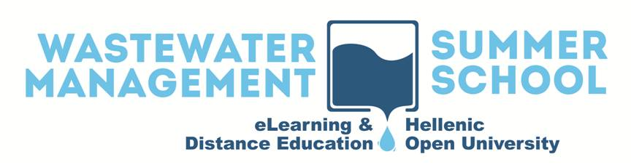

Patras, Greece, January,2019

5th distance education e-learning Summer School on "Wastewater and Biosolids Management" (WWSS19)

Dear Colleagues,

It is our pleasure to welcome you to the 5th distance education e-learning Summer School on "Wastewater and Biosolids Management" (WWSS19), taking place in Patras, Greece, July 22 - 27, 2019. This scientific event is organized in the context of the Postgraduate Study Programme “Waste Management”, by the Hellenic Open University.
The Summer School started in 2015 and was successfully continued since then with tens of wastewater and biosolids experts from many different countries worldwide (Bulgaria, Cyprus, Greece, Germany, Israel, Italy, Jordan, Oman, Philippines, Switzerland, Slovenia, Spain, UK, United Arab Emirates, USA, Tunisia, etc.), as keynote speakers.
The 2019 program follows the strategy of maintaining basic lectures enriched with new topics of interest on the new trends in wastewater and biosolids management technologies and representative case studies. As special features in 2019, the Summer School:
1) will dedicate a session on waste management of the Armed Forces,
2) will include a session, as in 2018, on practical laboratory exercises and data analysis tools for measuring the basic wastewater parameters requested by regulations,
3) will offer the possibility to master and PhD students as well as to wastewater and biosolids professionals, equipment suppliers, public bodies and organizations to present their work by e-posters (a one-page abstract should be sent to wastewater2019@eap.gr; the organizer will review this material and will timely inform about the acceptance of the presentation).
WWSS19 target group are all those interested in wastewater and biosolids management issues, worldwide. We would cordially like to invite all interested parties to register to the WWSS19 via its website, and to disseminate this educational event
Important Dates
01st February 2019: Available service for online Registration to the WWSS19 (at http://wastewater2019.eap.gr/).
01st June 2019: Deadline for the submission of e-posters one-page abstracts (abstracts to be sent to: wastewater2019@eap.gr).
08th July 2019: Notification of acceptance of e-posters.
15th July 2019: Deadline for the Registration to the WWSS19.
17th July 2019: Deadline for the submission of final e-posters.
22th – 27th July 2019: Thematic Sessions of the WWSS19.
Finally, we would like to express our warmest thanks to all those who have supported this effort since 2015, and especially the keynote speakers from the Hellenic and foreign Universities and research institutes, for contributing to a programme of such high quality.
We are confident that the participants of WWSS19 will both benefit from, and enjoy the programme.

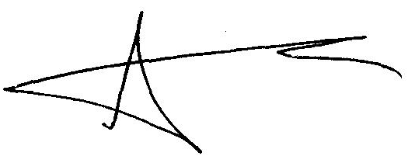
Sincerely Yours

Professor Dr. Ioannis K. Kalavrouziotis
Dean of the School of Science and Technology
Director of Postgraduate Master Program in ‘Waste Management’

