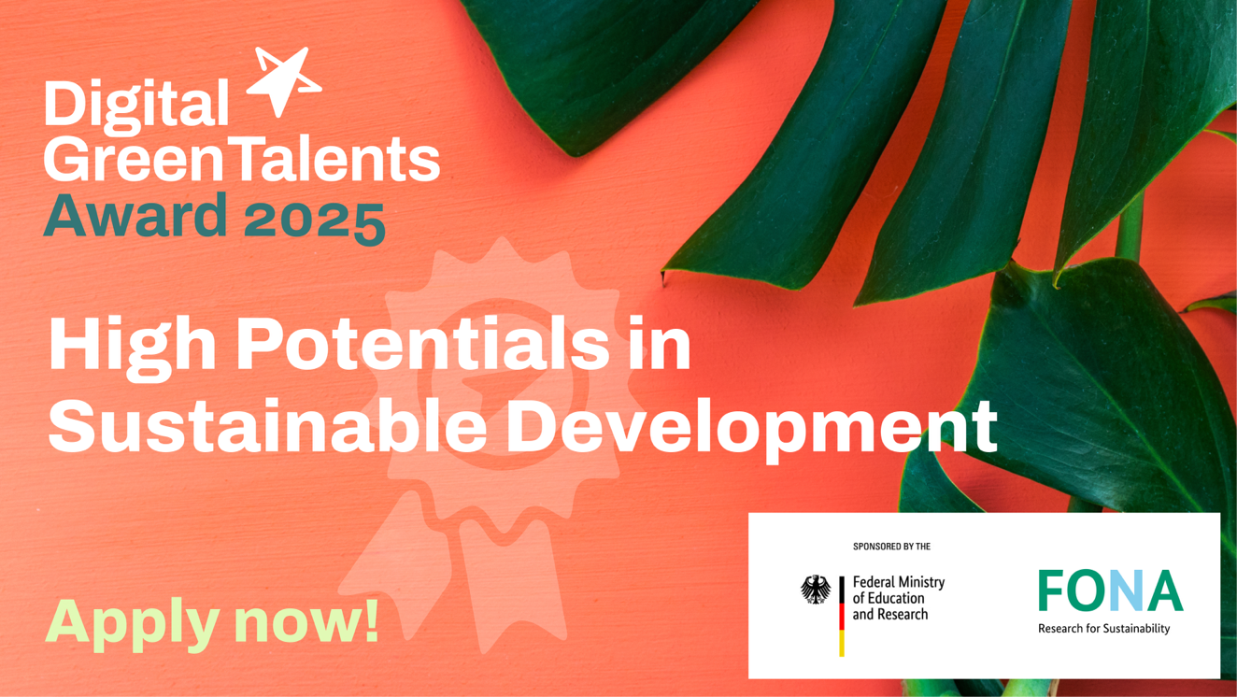

Communications-Kit Digital GreenTalents

Thank you for supporting the Digital GreenTalents Award! With this communication kit we want to make it as easy as possible for you to share the call for applications for the Digital GreenTalents Award. If you have any questions, please email us at maja.denisova@gi.de.
You can find a sharepic, a flyer and an announcement in PDF form in the cloud.

General text module for the Digital GreenTalents

How can digitalization contribute to a more sustainable future at a time when global climate change is challenging our current economic system and way of life?
How can we protect and preserve our environment through digital tools and approaches?
The German Federal Ministry of Education and Research (BMBF) promotes the Digital GreenTalents – High Potentials in Sustainable Development Award to find solutions to these urgent issues.
The award nominates 20 highly motivated and talented young scientists from all over the world with innovative ideas and a strong focus on digitalization and sustainable development. It supports the international exchange of innovative digital ideas to harness the power of the digital age for sustainable development and offers a great chance to establish a long-lasting cooperation with the German Digital GreenTech community.

Digital GreenTalents is realised by the Project Management Agency Karlsruhe at the Karlsruhe Institute of Technology (KIT) and the Gesellschaft für Informatik e.V. and funded by the German Federal Ministry of Education and Research (BMBF).

Social Media-channels (please tag)

LinkedIn: @Gesellschaft für Informatik e.V.
Mastodon: @informatik@mas.to
Instagram: @digitalgreentalents
Hashtag: #DigitalGreenTalents25

Instagram / Mastodon -Posts

- General post
Calling all international scientists working at the intersection of digitalization and sustainability to apply for the Digital GreenTalents Award 2025 funded by the Federal Ministry of Education and Research @BMBF_Bund! 🌍🏆 To apply, visit: http://digitalgreentalents.de #DigitalGreenTalents25

Sharepic here.

- General post addressed to researchers
Are you working at the intersection of digitalisation and sustainability? Do you want to join an international network of outstanding young researchers?
Applications for the #DigitalGreenTalents25 Award are open until 6 June!
More information here 👉 http://digitalgreentalents.de

Sharepic here.

LinkedIn-Post
Calling all international scientists working at the intersection of digitalization and sustainability to apply for the Digital GreenTalents Award 2025! 🌍
All information and the application form are published on the website: www.digitalgreentalents.de. Applications will be accepted until 6 June 2025.
🎓 The jury will select 20 international PhD students.
🏅 The prize consists of a fully-funded research stay in Germany, participation in the SpringSchool, a Mentoring programme and the chance to join the global Digital GreenTalents network!
The award is funded by the Bundesministerium für Bildung und Forschung and organised by the Projektträger Karlsruhe (PTKA) am Karlsruher Institut für Technologie (KIT) in cooperation with the German Informatics Society. #DigitalGreenTalents25

Sharepic here.

Text module for newsletter

How can digitalization contribute to a more sustainable future at a time when global climate change is challenging our current economic system and way of life?
How can we protect and preserve our environment through digital tools and approaches?
The German Federal Ministry of Education and Research (BMBF) promotes the Digital GreenTalents – High Potentials in Sustainable Development to find solutions to these urgent issues.
The Digital Green Talents Award selects 20 highly motivated and talented young scientists from all over the world with innovative ideas and a strong focus on digitalization and sustainable development. The prize consists of a fully-funded research stay in Germany, participation in the SpringSchool, a Mentoring programme and the chance to join the global Digital GreenTalents network.

For more information, visit www.digitalgreentalents.de
Deadline for submission is June 6, 2025, 02:00 p.m., CEST.

Sharepic here.

Contact

Maja Denisova
Project Manager
German Informatics Society
Maja.denisova@gi.de
+49 (0) 1556 6343494



