Cannot open the email? | View in your browser

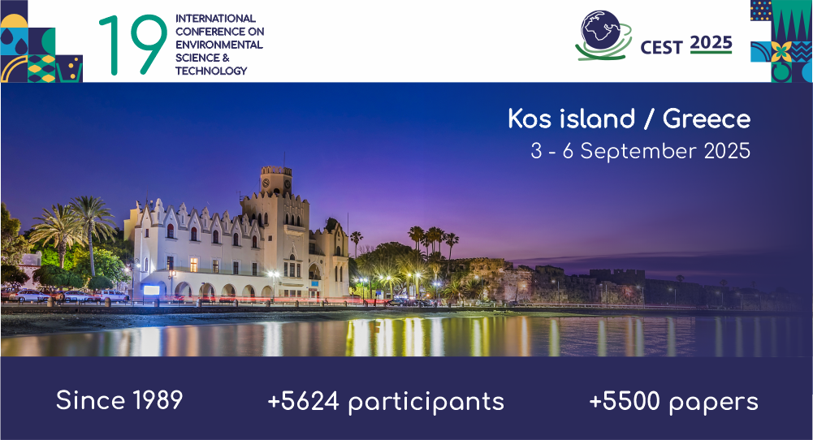

  SUBMIT YOUR PAPER
  REGISTER

Submit your abstract by 28 of February and join us in Kos!
Dear colleagues,
Thank you for your great interest in joining CEST2025! Abstracts are keep coming from all over the world! We have decided due to your requests to extend the deadline for the abstract submission until 28 February 2025.
The 19th International Conference on Environmental Science and Technology - CEST2025, will be held on Kos Island, Greece, from 3 to 6 September 2025 and is organized by the Global Network of Environmental Science and Technology jointly with the University of the Aegean (Greece), the University of Salerno (Italy), and the Open University of Cyprus (Cyprus).

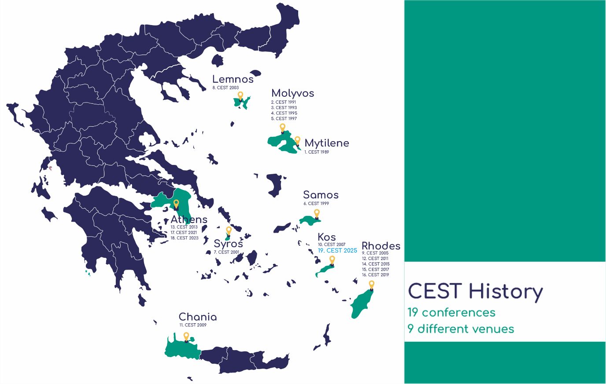

A few words about the conference venue, Kos island
Nestled right opposite the coast of Turkey, in the heart of the Aegean archipelago, Kos is a genuine Greek Island that belongs to the Dodecanese Island complex. Kos effortlessly blends the old with the new, boasting dozens of easy-to-reach beaches, several historical landmarks, lush vegetation and heavenly teal-blue waters attracting +1000000 visitors annually. The island is located 338 km (210 miles) from Athens, it has a coastline of 112 kilometres and a population of approximately 35.000 people. Its recently renovated international airport, Hippocrates, offers daily flights to Athens and links Kos to several European countries.
Kos stands out as the Dodecanese’s premier beach destination; a true Mediterranean oasis both for history enthusiasts and adventure seekers. Its vast vegetation, mild climate, Aegean-blue waters and never-ending coastlines form a scenery of extraordinary beauty, ideal for summer holidays.
The island has a rich history dating back to prehistoric times, about 3.000 BC. It is also often described as an open-air museum, and rightly so, featuring dozens of archaeological sites and offering plentiful cultural events throughout the year. Hippocrates (460-377 BC), the father of medicine and author of the Hippocratic Oath, practised and taught his medicine in the ancient Asklepion, one of the most emblematic landmarks preserved in the countryside of Kos. Many and diverse historical monuments are a testament to the crossroads of civilisations that once bloomed on the island. Churches, Ooman mosques, distinctive roman architecture, exotic palm trees, and of course, Mediaeval castles, form an extraordinary fusion of outstanding cultural landscapes and natural beauty.
Source: https://kos.gr/

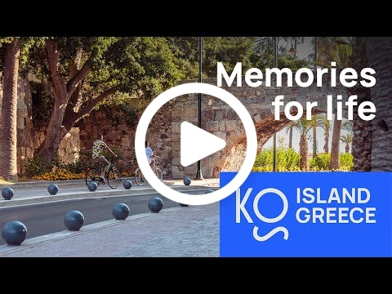

Conference topics
CEST2025 is announced at a pivotal time when the intensifying climate crisis is challenging the resilience of societies worldwide and reshaping the planet’s natural systems. Climate change is linked with the depletion and contamination of water resources, a problem exacerbated by the increasing frequency of extreme weather events. Effective wastewater treatment and innovative water management practices are essential in addressing this scarcity while minimizing pollution that threatens ecosystems and public health. Biodiversity, already under severe strain from habitat loss and environmental degradation, faces even greater threats as shifting temperatures disrupt ecosystems and the species that rely on them.
CEST2025 will also explore the role of a circular economy in mitigating these impacts by reducing waste, promoting sustainable resource use, and driving innovations that foster environmental and economic resilience. Bringing together experts from multiple fields, this event aims to catalyze collaborative solutions for a more sustainable future.
Take a look at CEST2025 thematic areas

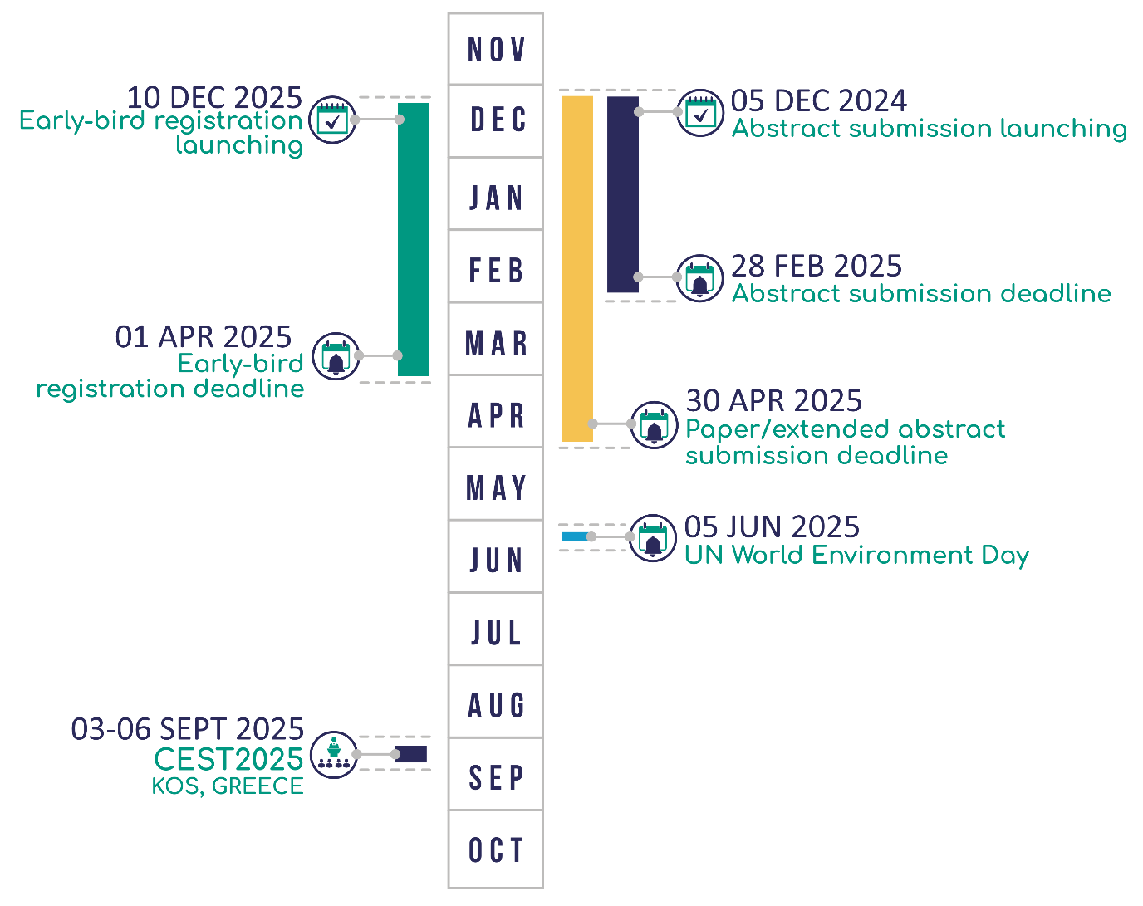

Why submit to CEST2025?
- Present your research to an international audience of experts and stakeholders.
- Collaborate with leading academics, innovators, and policymakers.
- Contribute to the development of actionable solutions for urgent global environmental challenges.
- Experience the inspiring environment of Kos Island, a vibrant coastal destination with a rich heritage.
This long-standing conference series has fostered collaboration and innovation in various Greek islands, while the last two events were held in Athens. We are now excited to re-establish our connection with Greece’s coastal heritage, embracing Kos Island’s inspiring environment to advance discussions on critical environmental issues.
We look forward to your contributions and to welcoming you to CEST2025!
Demetris-Francis Lekkas, Chair
University of the Aegean, Greece
Vincenzo Belgiorno, Co-chair,
University of Salerno, Italy
Antonis Zorpas, Co-chair
Open University of Cyprus, Cyprus



Conference Secretariat
tel: +30 6984027379
e-mail: cest@gnest.org, web: https://cest.gnest.org/

  Follow us
     | ⠀
      
     | ⠀
      
     | ⠀
      
     | ⠀
      

This email was sent to dlekkas@env.aegean.gr because you've opted-in to receive news and promotional emails from us. Click here to unsubscribe.

​
Click on me

