Cannot open the email? | View in your browser

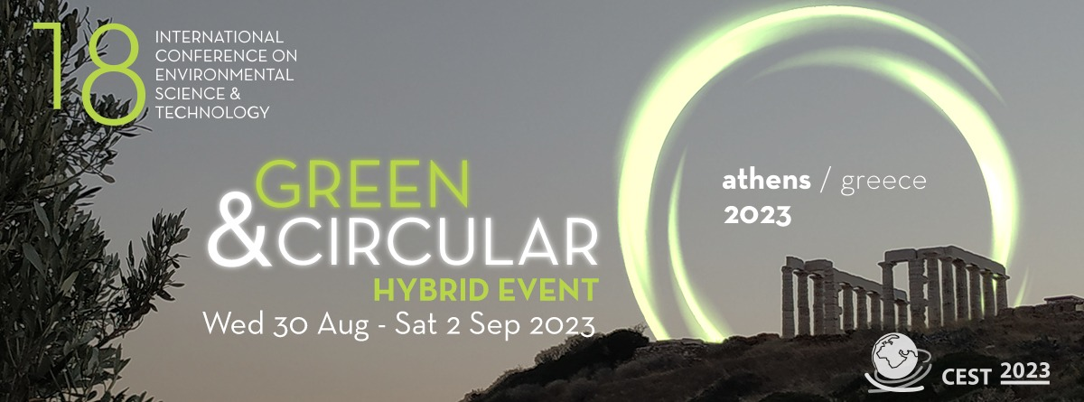

ANNOUNCING CEST 2023

Deadline for the abstract submission is approaching
We invite you to participate in the 18th International Conference on Environmental Science and Technology (CEST2023). The conference will be held in Athens, Greece from 30 August to 2 September 2023.
Established in 1989, CEST is a leading environmental conference where top experts, scientists, entrepreneurs, representatives of public administration and social initiatives present state-of-the-art research on current and emerging environmental issues. CEST2023 is announced in a time of transition from linear economic models to circular economy and bioeconomy worldwide. These topics as well as emerging research fields of the environmental sector will form the basis for scheduling sessions and side events.
The conference is organized by the Global Network of Environmental Science and Technology jointly with the University of the Aegean (Greece) and the National and Kapodistrian University of Athens (Greece). It is scientifically supported by the Open University of Cyprus (Cyprus), the University of Salerno (Italy) and the University of Cincinnati. The conference is under the auspices of the Region of Attica and the Municipality of Athens with the support of World Water Assessment Programme of UNESCO and the International Water Association (IWA). The nongovernmental organization Prince Sultan Bin Abdulaziz International Prize for Water (PSIPW), is collaborating with CEST and offers travel grants to students and researchers from low-income countries.
The previous event (CEST2021) was a great success. gathering over 600 participants from all over the world. During CEST2021, 58 sessions were organized and over 550 papers were presented along with 18 invited and keynote speeches.
Our conference is peer-reviewed. All the papers that are selected for either oral or poster presentation undergo a review process. CEST proceedings are identified by ISSN 2944-9820. The papers from the last conferences (2019 and 2021) are assigned a DOI number. You can track them by conference and topic here.

SUBMIT YOUR PAPER

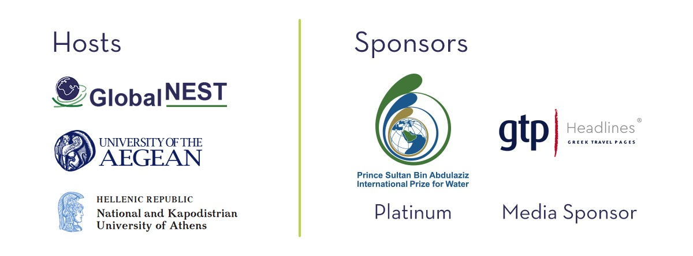

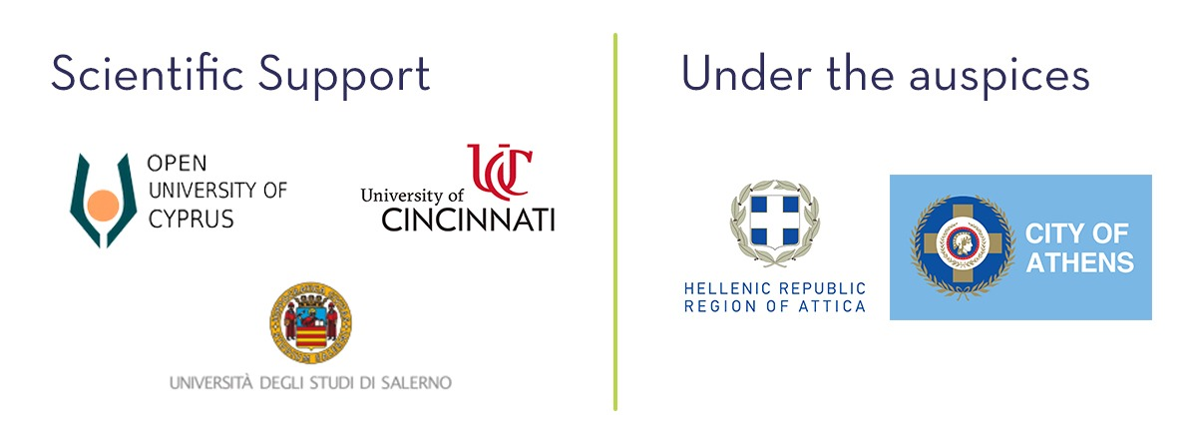



  Follow us on:
    
    
    
    

