University of Piraeus, Dept of Maritime Studies
MSc "Sustainability and Quality in Marine Industry”
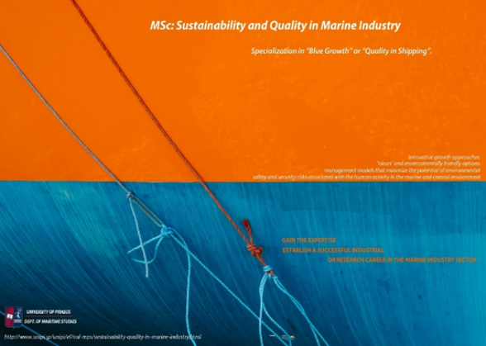
Blue Economy has an immense current and potential future value providing resources, growth and jobs. Blue Economy sectors need highly qualified and skilled professionals. The new MSc "Sustainability and Quality in Marine Industry”, of the Dept of Maritime Studies of the University of Piraeus, satisfies the great need for “blue” specialists by offering new knowledge on cutting-edge topics. It aims to make its graduates highly attractive in today’s competitive job market by qualifying them for a wide range of careers.
It is a 12-month intensive course in English addressing the current challenges in the marine industry. It incorporates innovative growth approaches, "clean" and environmentally friendly options as well as management models that minimize the potential of environmental, safety and security risks. It offers two specializations, which are Blue Growth and Quality in Shipping. Its attendees will focus on topics such as Integrated Coastal Zone Management, Marine Spatial Planning, Remote Sensing, Geographical Information Systems, Blue Growth sectors, Environmental Pollution and Management, Marine Governance, Quality and Safety, Shipping Pollution and Ship Efficiency.
Its graduates will get a theoretical and practical understanding of the latest developments for sustainable growth in the marine and maritime sectors. Moreover, they will be offered certified training in the area of management systems by internationally accredited training agencies, which gives them a unique and competitive advantage.
We strongly believe that the MSc “Sustainability and Quality in Marine Industry” creates new jobs profiles and more chances for blue jobs’ opportunities.
Deadline for applications 31st July 2019.
For more information, please visit the site:
http://www.unipi.gr/unipi/el/naf-mps/sustainability-quality-in-marine-industry.html
For call for applications, please visit the site:
http://www.unipi.gr/unipi/el/naf-mps/sustainability-quality-in-marine-industry/announcements-of-m-sc-sustainability-and-quality-in-marine-industry.html

