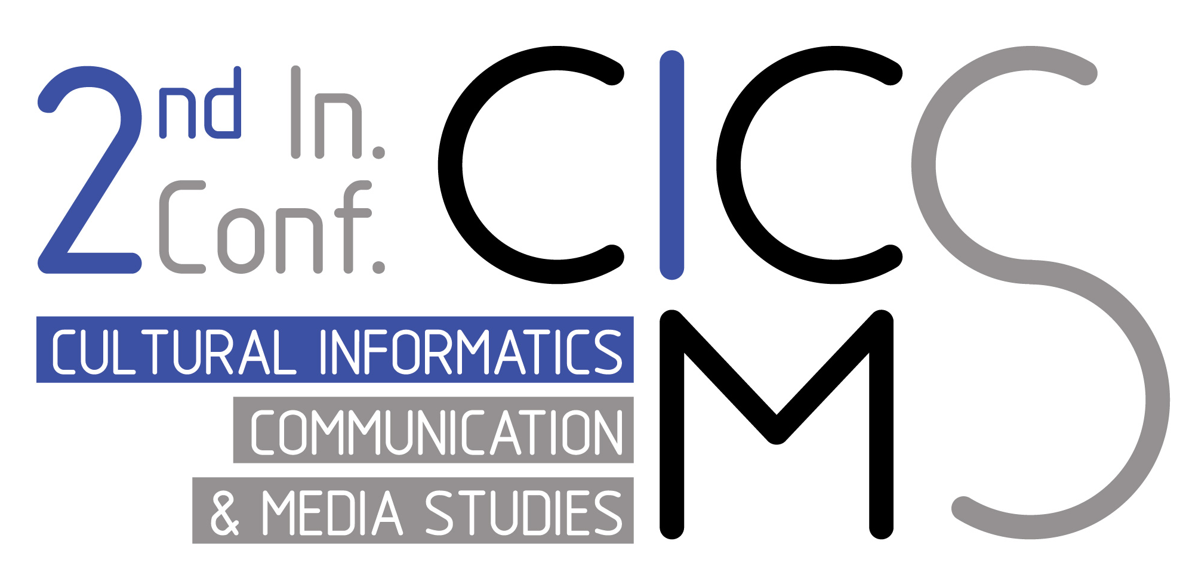

CALL FOR ABSTRACTS

2nd International Conference on Cultural Informatics, Communication &
Media Studies

The purpose of this conference is to come together with scientific studies scholars working in different disciplines, to exchange knowledge and experiences and thus to prepare the ground for multidisciplinary studies. The conference will bring together leading academic scientists, researchers and scholars in the domain of interest from around the world. You are kindly invited to participate and take advantage of the opportunity to present your unpublished abstracts. The official language of the Conference is English. The conference will be powered by the University of the Aegean, Department of Cultural Technology and Communication (Greece) and the Adnan Menderes University, Faculty of Communication (Turkey).

Topics

The aim of the specific conference is to provide researchers and professionals the opportunity to publish novel and cutting-edge research to topics such as:
- Cultural Informatics
- Communication
- Media Studies
- Journalism
- Radio
- Television
- Cinema
- Advertising
- Public Relations
- Management
- Economics
- Political Science
- Human Resources
- Social Media
- Photography
- New media
- Communication in education
- Distant education in communication
- Communication ethics
- and other topics that are related to communication, media studies

Submission

Authors are invited to submit their abstracts through the CICMS submission site (Easychair):
https://easychair.org/conferences/?conf=cicms2019

All authors must be aware of the following rules prior to abstract submission:

- All abstracts will be reviewed by the program committee members and the corresponding authors will receive a notification about the review results
- At least one of the authors listed should attend the conference in person and present the abstract orally.
- One author can submit more than one abstracts. However, the registration applies for every abstract independently.
- Abstracts previously presented won’t be accepted
- All abstracts should be submitted in English or Turkish. The official conference language is English. However, dedicated sessions in Turkish may be organized in parallel.
- All abstracts accepted for presentation will be published in online Proceedings.
- Selected abstracts will be published as full papers on separate Conference Proceedings after the completion of CICMS2019.

Presenting Authors are requested to create an account in easychair submission site and submit an abstract for review according to the guidelines set out above. Should you require any assistance or have a query about online submission, contact the organising committee members at cicms2019@easychair.org .

Important Dates

Submission Deadline: 15 April 2019 30 April 2019 (11:59 p.m. Athens, Greece time GMT+2)
Notification to Authors: 2 May 2019 5 May 2019

Organization

General Chairs
- Prof. Papageorgiou Dimitris, University of the Aegean, Greece
- Prof. Halim Esen, Adnan Menderes University, Turkey

Program Committee Chairs
- Assoc. Prof. Christos Kalloniatis, University of the Aegean, Greece
- Assoc. Prof. Mustafa Özgür Seçim, Adnan Menderes University, Turkey

Program Committee Members

– Prof. Anagnostopoulos Christos-Nikolaos, University of the Aegean, Greece
– Assist. Prof. Dr., Aslı İcil Tuncer Aydın, Adnan Menderes University, Turkey
– Asst. Prof. Catapoti Despona , University of the Aegean, Greece
– Prof. Dr. Ebru Uzunoğlu, Izmir University of Economics, Turkey
– Prof. Dr. Filiz Tiryakioğlu, Anadolu University, Turkey
– Assist. Prof. Dr. Gülcan Şener, Trabzon University
– Assoc. Prof. Dr. Hatice Hale Bozkurt, Aydın Adnan Menderes University, Turkey
– Assoc. Prof. Dr. İçten Duygu Çallı, Aydın Adnan Menderes University, Turkey
– Prof. Katos Vassilis, University of Bournemouth, Greece
– Assoc. Prof. Kavakli Evangelia, University of the Aegean, Greece
– Asst. Prof. Kavroudakis Dimitris, University of the Aegean, Greece
– Dr. Kitsiou Angeliki, University of the Aegean, Greece
– Prof. Lambrinoudakis Costas , Univeristy of Pireus, Greece
– Assoc. Prof. Dr. M. Özgür Seçim, Aydın Adnan Menderes University, Turkey
– Assist. Prof. Dr. Mehmet Özbek, Aydın Adnan Menderes University, Turkey
– Dr. Sideri Maria, University of the Aegean, Greece
– Dr. Simou Stavros, University of the Aegean, Greece
– Assoc. Prof. Skopeteas Yiannis, University of the Aegean, Greece
– Asst. Prof. Topouzelis Kostantinos, University of the Aegean, Greece
– Prof. Tsekouras George, University of the Aegean, Greece

Conference Web Page:

http://cicms2019.aegean.gr/

For any inquiries please contact the PC Chairs at: cicms2019@easychair.org

