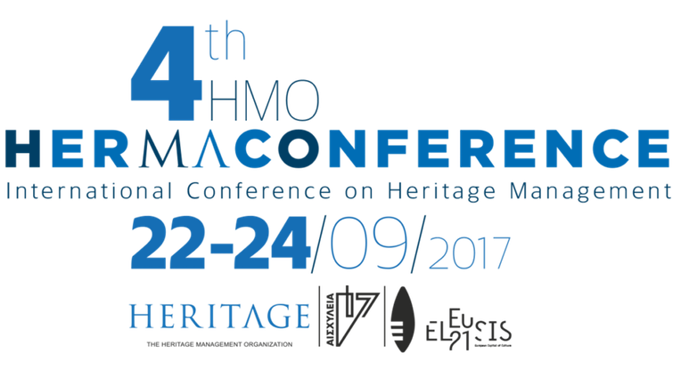
Dear Friends
(and please forward this to your own networks),

The Heritage Management Organisation is pleased to invite you to participate in the 4th HMO International Conference on Heritage Management, which will take place at Paleo Eleourgio (Old Oil Factory), in Elefsina, Greece between 22-24 September 2017. This year’s conference has expanded its content and actions: it aspires to achieve a dynamic presence on the global scene, given that it is being conducted under the auspices of Eleusis Cultural Capital 2021 and the Aeschylia Festival. In 2017 Italy is the Honoured Country.

The aim of the conference is the discussion and development of best practices in heritage management through case studies from all around the world. Of particular concern are key fields such as heritage conservation and digitization, public engagement, education and legal protection.

From 2017 and onwards the HerMa Conference will adopt the strategy of an annual Umbrella Theme. The 4th HMO International HerMa Conference inaugurates this practice with a debate that is considered to be crucial for the future in heritage management and preservation. Thus the core concern for 2017 is the notion of ruins in culture: the topic may be expressed – “Monuments in Ruins---Ruins as Monuments”.

International professionals and academics, with distinguished presences in their respective fields, will deliver keynote speeches in each thematic session. Within the conference framework, side events [HerMa Market, Eleusis: Visions for the Industrial & Archaeological Heritage, Aeschylus: The Eternal Battle, HerMa: Street Art, Ruins and the Contemporary City, NewUse Heritage, Capture Heritage Images] will explore such themes through experiential learning processes, interactive dialogue and involvement of the participants.

For more information about the conference and its side events, please visit the website: www.inherity.org/conference/
​
Do not hesitate to contact us, please, should you have further queries regarding the conference.
In anticipation of your support and participation,

The Organising Committee
E: inherity.conference@gmail.com

