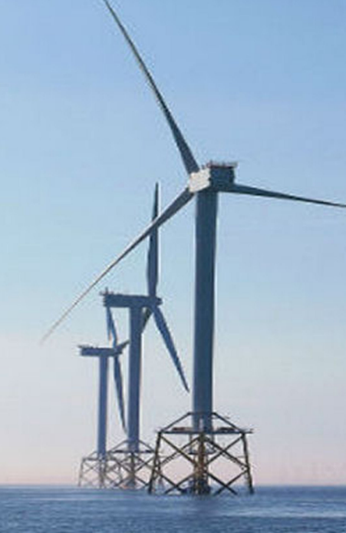
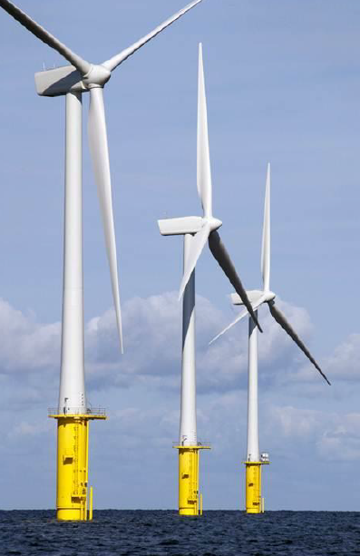

Course title: “Training course on design of offshore wind turbine structures”
Contents of the course:
- Introduction to the wind energy engineering
- Structural engineering in wind energy harvesting
- Modelling of loads on offshore wind turbines
- Probabilistic approach in the design of offshore wind turbines

- Research engineer and a PhD candidate at the Institute for Steel Construction of Leibniz University Hannover.
- Currently working on a project of the European Commission’s Framework Program “Horizon 2020”, through the Marie Skłodowska-Curie Innovative Training Networks (ITN) “AEOLUS4FUTURE - Efficient harvesting of the wind energy”
- Field of expertise: Advanced reliability analysis of offshore wind turbine structures
E-mail: glisic@stahl.uni-hannover.de

ANA GLIŠIĆ

