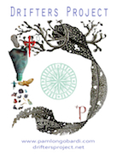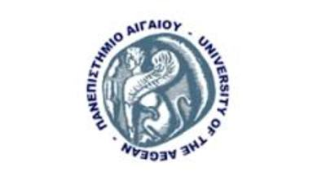

PROPOSAL FOR COLLABORATION with University of the Aegean community

Pam Longobardi, Distinguished Professor, Georgia State University and Founder, Drifters Project

This past May, I was honored to visit the University of the Aegean to present my work at the ISISA conference. I was greatly moved by the experiences I had on Lesvos, from the wonderful people I met and talks I heard at ISISA, to working in the refugee camps with volunteers, to the unnerving spectacle of the ‘cemetary of the lifevests’. I invite you to read my blog article: http://driftersproject.net/blog/2016/07/08/lesvos-heartbreak-and-joy-in-equal-measure/

I am proposing an art project to collaborate with interested students and citizens of Lesvos and refugee groups like Lesvos Solidarity to create a large-scale artwork that would help tell the story of Lesvos circumstance as a haven for refugees. My idea is to stitch together a monumental flag that would become a symbol for the new nation of climate refugees. As citizens without a nation, the flag could be hoisted in various locations around the world to symbolize islands that have been sanctuary to refugees in the past, the present, and certainly, in the future. Its first stop would be in NY, where I have an exhibition in May. There is discussion underway with the mayor of Kangaroo Island in Australia for the artwork to travel there in July for the next ISISA conference, providing a link to Lesvos, and to tell the story of this new international population of climate refugees. The Mayor also wishes to facilitate the project’s tour around Australia. I also have interest to display this work in Athens and also in Kefalonia, which would bring the project back to Greece in full circle.

I propose to offer this to participants as a special seminar/ short course that would involve not only the physical work of collecting and dismantling the life vests, but lecture and discussion to put this action in the context of the Anthropocene, the current geopolitical circumstances of climate change and migration, and art/science/activism as a tool for awareness and social change. I could offer a kind of certification for participants as an international collaborative art/social awareness project. As I will carry this work on with my own students back in Atlanta at Georgia State University, it would be possible to sew seeds for a future collaboration and exchange between GSU and University of the Aegean.

Thank you for your support and consideration.

